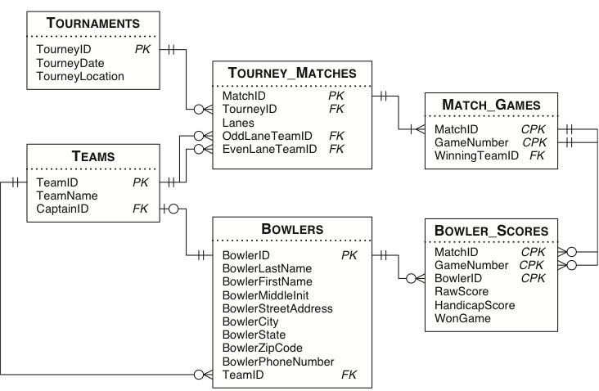
- Create View to display name of all bowlers (1 point)
- Create View to display tournament played in ‘Imperial Lanes’ location (1 point)
- Create View to display the bowlers who has highest raw score for each team (1 point)
- Create View to display the total number of lanes played for each tournament (1 point)
- Show the team winner name for each game (1 point)
- Show only 56 matches played in all tournament, and winner team and loser team for each match (1 point)
- What team win more in odd lane than even lane (1 point)
- List all bowler info for each team and indicate who is MVP player (MVP player is the one has the highest average score of all games for that team) (1 point)

